Journal of Asian Multicultural Research for Economy and Management Study | ISSN: 2708-9711  Vol. 5 No. 3, 2024 (page 025-041)  DOI: https://doi.org/10.47616/jamrems.v5i3.536
Business Ecosystem Architecture Development: A Case Study of IoT Business in the Transportation Industry
Rahmat Hardian Putra¹, Mohammad Riza Sutjipto¹, Aji Widodo², Sri Kuntadi²
Email: rahmat.putra@telkom.co.id
¹Master of Management, Telkom University, Bandung
²Telkom Indonesia, Bandung

Received: July 21, 2024
Received in revised: August 16, 2024
Accepted: September 15, 2024
Abstract
The research aims to study business ecosystem architecture in the Internet of Things (IoT) scope, especially in the transport industry. This research uses a qualitative approach with the Research and Development (R&D) method with the Modeling Business Ecosystem Architecture (TEAM) research design. Informants consist of internal and external sources who provide a practical and comprehensive perspective on the IoT transportation business ecosystem at Telkom Indonesia. Data collection was conducted through in-depth interviews, observations, and literature studies. The results showed that, in mapping the IoT business ecosystem in Telkom Indonesia’s transportation sector. The findings highlighted several challenges, such as the limited readiness of human resources and the lack of local device manufacturers resulting in a lack of competitiveness of IoT solutions. There is a need for a business ecosystem architecture that focuses on examining actors, roles, and value offered and mapping interactions between actors. With a co-creation approach, actors in the ecosystem can actively collaborate in designing, developing, and implementing more innovative and adaptive solutions. Through the co-creation process, customers, service providers, application developers, and other actors can share knowledge, experiences, and resources to create solutions that better suit the needs and expectations of all parties involved. This research maps the IoT business ecosystem in the transport sector developed by Telkom Indonesia. Telkom Indonesia is a solution provider, where the importance of collaboration of each actor, including device providers, application developers, and customers, is crucial to overcoming challenges and maximizing the ecosystem’s potential.
Keywords: Ecosystem Architecture; Business Ecosystem; Internet of Things (IoT), Transportation
Introduction
The potential of the IoT business in Indonesia is currently growing along with the dynamics of digital economic development. The IoT business market in Indonesia is predicted to reach US$40 billion, by 2025 with 678 connected IoT devices (Yulianto, 2023). Ministry of Communications and Informatics in 2025 also predicted rapid growth in the adoption of IoT technology, with an annual growth trend exceeding 15% CAGR up to. Indirectly, this growth makes companies offer many IoT-based products. Several companies in the manufacturing, smart city, smart home, and logistics sectors are utilizing IoT as their flagship product.
Telkom Indonesia, with the advantage of technology-based products, is developing IoT services as part of digital platforms and digital services. In 2021, Telkom Indonesia’s revenue was dominated by non-digital legacy business (66%), while the digital sector only contributed 34%, showing a potential gap. The contribution of the digital sector consists of 18% from digital services and 16% from digital platforms. Although the IoT business in Indonesia is estimated to reach IDR 444 trillion by 2022, Telkom only controls 0.70%, showing a huge opportunity that has not been optimized. Another problem experienced by Telkom Indonesia is also related to the low revenue margin in the IoT business, which is due to the large capital investment in the provision of devices, which covers ± 60% of the total investment. Telkom Indonesia ultimately partners with quality device providers to fulfill the needs of the value chain. Despite targeting the business-to-business (B2B) segment to support all sectors with IoT product development, the demand for IoT solutions is still low due to the large initial investment. This shows that despite the opportunity, the IoT business faces the challenge of low profitability. Telkom Indonesia is currently focusing on developing the IoT business in the transport sector. It is undeniable that the IoT business in the transportation sector has many competitors, thus creating intense competition. The need for Telkom Indonesia to use the right and mature business ecosystem approach is one of the urgent needs to maximize the potential of the digital sector, especially in facing the challenges of low margins and taking advantage of the huge opportunities in the IoT market.
Business ecosystems enable collaboration between companies across industries and engage customers as value co-creators, moving the focus from the enterprise to the network. IoT business success depends on the readiness and maturity of the ecosystem (Chan, 2015). Research by Bai et al., (2018) states that IoT itself represents a complex ecosystem, which involves interactions between various devices and technologies in the IoT technology landscape. This characteristic shows the importance of understanding the IoT business ecosystem in a broader context, including its relationship with various elements in related industries. Meanwhile, Rong et al., (2015) also revealed that the IoT-based business ecosystem is more than just a supply chain with connected goods. By using the 6C framework (context, cooperation, construct, configuration, capability, and change), patterns of IoT-based business ecosystems can be identified and offer practical implications for designing future business ecosystems. The implementation of this business ecosystem makes Telkom Indonesia need to formulate and highlight its Unique Value Proposition (UVP) carefully to differentiate itself and gain a competitive advantage in the transportation industry IoT business market. Ma et al., (2021) revealed that business ecosystem modeling can be done by focusing on core elements, actors or roles, and interactions to create shared value. Tricahyono & Purnamasari (2018) also revealed that the role of various actors in the business ecosystem needs to see the role and relationship of each actor. Future evaluation and strategic planning are very important, involving all actors to create a healthy and sustainable business ecosystem. In the problem of IoT development in the transportation sector at Telkom Indonesia, it has not explicitly utilized structured business ecosystem modeling and involved the roles and relationships of all actors optimally.
The absence of business ecosystem architecture modeling by Telkom Indonesia is one of the state of the art in this research. Not many studies have examined aspects of business ecosystem architecture that focus on core elements, actors, roles, and interactions to create shared value in product development, so this is one of the potential important contributions of this research. This research will fill the gap in the literature by exploring comprehensive business ecosystem modeling, which can be a reference in IoT-based product development strategies. Thus, this research uses a business ecosystem architecture design approach to be able to develop relevant innovations, strengthen the relationship of each actor in the ecosystem, and ensure the suitability of the business model to customer and market needs for long-term growth and success.

Literature Review
In many cases, the terms and concepts of business ecosystems and ecosystems in digital platforms are often equated. However, an academic study conducted by Helvetia Innovation Lab points out the need to make a clear distinction between technological factors and cooperation models (Lingens et al., 2019). Technology platforms are generally used to reduce transaction costs between partners in the ecosystem. Therefore, the platform ecosystem is only a means to achieve efficiency in organizing the business ecosystem. This is the difference with platform ecosystems. The core function of the platform ecosystem is to generate network effects, and as the number of providers on the platform increases, the benefits to customers also increase. The more customers who use the platform, the more providers are attracted to join (Panico & Cennamo, 2022).
In the beginning, business ecosystems tend to be fragmented with industrial systems that have separate roles. As it evolves, the ecosystem develops several dominant supply chains and manages to form an established industrial system, creating value for all stakeholders at the maturity stage (Ma et al., 2021). The development of a business ecosystem architecture proposes essential elements consisting of systems engineering, ecology, and business ecosystem. This process can be divided into three main parts: business ecosystem architecture development, factor analysis, and ecosystem simulation and reconfiguration (Figure 1).
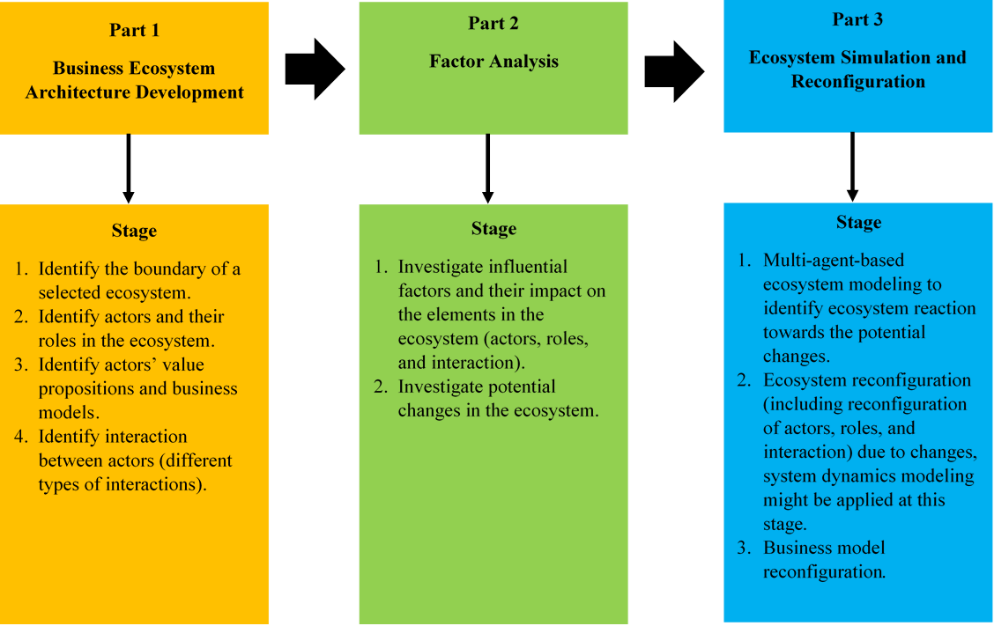
Figure 1. Business Ecosystem Architecture Framework and Steps
Source: Ma et al., (2021)
The framework developed by Ma et al., (2021) provides an overview of business ecosystem architecture steps that aim to identify the target business ecosystem and its elements consisting of actors, roles, and interactions. The business ecosystem architecture model is also discussed by Radonjic-Simic & Pfisterer (2019) that the elements of actors, roles, and their interactions are considered to correlate with each other in the ecosystem structure. This interaction in an ecosystem determines the roles and relationships between actors, which will ultimately shape the value of the form of cooperation carried out (Adner, 2017; Zhang et al., 2016). The business ecosystem model is an approach used to understand and analyze the complex relationships between various business entities in an environment. By building an ecosystem architecture model, attempting to identify key actors and their contributing roles and values, and analyzing the interactions between them, this approach provides a solid framework for understanding the complexity of business relationships.
Methods
This research uses a qualitative approach with the Research and Development (R&D) method with the Modeling Business Ecosystem Architecture (TEAM) research design. This type of modeling business ecosystem architecture (TEAM) method was introduced by Wieringa et al., (2019) which explains that this method can identify and map ecosystem architecture to technical infrastructure by modeling value exchanges between actors, such as the value network of an ecosystem. By taking a case study of the development of IoT business ecosystem architecture in the transportation sector at Telkom Indonesia, it aims to design and implement a business ecosystem model that suits the needs and challenges of the transportation industry.
The selection of informants as key persons or main informants in the research will be carried out from both internal and external sides of the company. From the internal side, the respondents come from Telkom Indonesia’s senior or middle manager officials at Tribe IoT in Telkom Indonesia’s Digital Business & Technology Division, who play a role in decision-making and strategy determination in Telkom Indonesia’s IoT business, so that the research can dig deep insights into the company's vision, strategy implementation, and industry dynamics. While from the external side, the respondents will be represented by customers who use IoT services to explore the opportunities and threats of this business and can simultaneously compare with competitors in this business.
The data collection techniques used were interviews, observations, and literature studies. This research makes an important contribution to understanding the dynamics that occur in IoT businesses at the interacting ecosystem level. In this approach, the focus is on one particular entity or organization that implements an IoT platform, enabling an in-depth investigation of the strategies and business models implemented. The analysis techniques included manual coding of the data to find the main categories related to the business ecosystem architecture, as well as the application of the TEAM model to visualize the value exchanges and information flows between the actors.
In the process of developing a business ecosystem architecture model, it is adopted from the modeling stages presented by Ma et al., (2021), which consist of four stages. In the first stage, the identification of business ecosystem boundaries will be examined with PESTEL, SWOT, and Porter 5 Forces analyses. Using these types of analyses, the business ecosystem will be comprehensively identified to identify external and internal factors that affect the performance and sustainability of the ecosystem (Putera & Heikal, 2021; Danivola & Kuznetsova, 2020; Kreutzer, 2019). The second stage is to identify the actors and their roles in the business ecosystem. The third stage is to identify the value of each actor. The fourth stage is identifying interactions between actors. And the last stage, verifying the design of the IoT business ecosystem architecture model in the transportation sector at Telkom Indonesia.
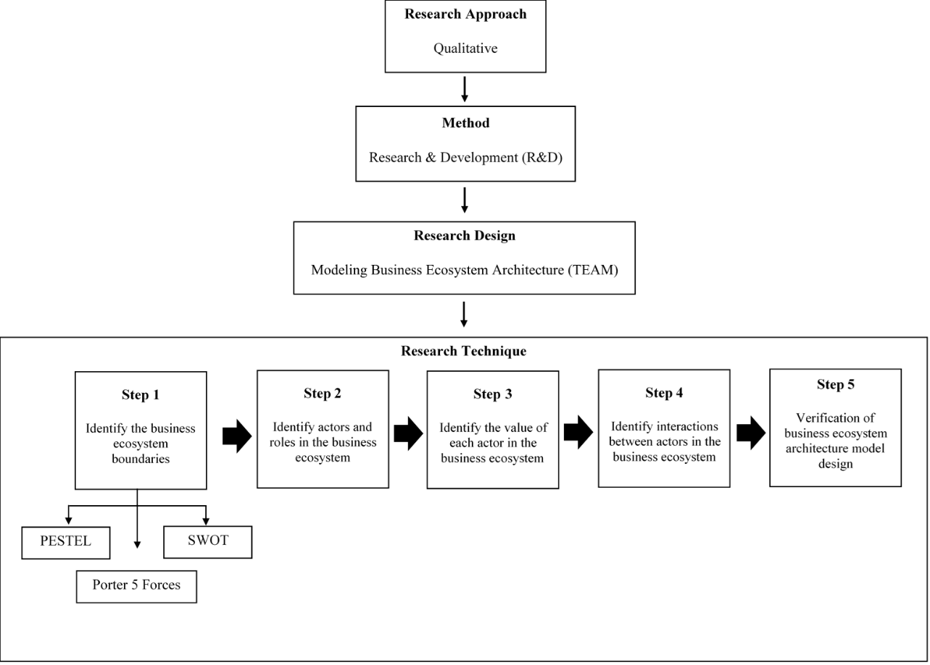
Figure 2. Overview of Business Ecosystem Architecture Research and Development Process
Results and Discussion
Identify the Business Ecosystem Boundaries
In this section, the ecosystem boundary analysis will be examined using PESTEL, SWOT, and Porter 5 Forces. The following is the explanation:
Table 1. PESTEL Analysis
PESTEL Indicator | Findings
Political | Telkom Indonesia is leveraging Presidential Regulation 122/2016 to enhance its IoT services, focusing on improving operational efficiency, safety, and user experience. The move aligns with the 2020-2024 National Medium-Term Development Plan and Sustainable Development Goal, ensuring the country's transportation infrastructure development.
Economic | Telkom Indonesia is leveraging IoT technology to enhance operational efficiency and develop new services in the transport industry, aligning with its strategy to expand market share and create value. IoT services like fleet management contribute to national productivity and competitiveness.
Social | Telkom Indonesia is leveraging IoT systems like IndiCar to enhance user experiences and strengthen its brand image. With a high reliance on private transport, the company is continuously innovating to provide efficient, convenient, and safe transport solutions. This not only increases customer satisfaction but also strengthens long-term relationships with consumers.
Technological | Telkom Indonesia uses IoT-based transport services for real-time vehicle monitoring, safety, and maintenance. The technology enhances fleet management, operational efficiency, and security, while implementing a recurring cost model, making it the leader in technology-based transport solutions in Indonesia.
Environment | Telkom Indonesia is utilizing IoT services like IndiCar to achieve Sustainable Development Goals by reducing environmental impacts and promoting green transportation practices. This efficient system reduces emissions, energy consumption, and travel costs, fostering sustainable economic growth.
Legal | Indonesia’s IoT adoption is bolstered by a robust regulatory framework, ensuring safe and reliable IoT networks. However, challenges like overlapping regulations between central and local governments hinder growth. Telkom Indonesia must advocate for a coordinated regulatory framework to support industry growth.
Based on the results of the PESTEL analysis in Table 1, it shows that Telkom Indonesia strategically leverages political regulations, IoT technology, and social needs to strengthen its position in the transportation industry. Political factors such as Presidential Regulation 122/2016 support the development of IoT services in line with national development plans and the Sustainable Development Goals. From an economic perspective, the development of IoT technology enhances operational efficiency and national competitiveness. Socially, Telkom Indonesia enhances user experience and brand image through continuous innovation in transportation solutions. The IoT technology used not only enhances efficiency and security but also positions Telkom as a leader in technology-based transportation solutions in Indonesia. From an environmental perspective, this company contributes to reducing environmental impact through greener transportation practices. However, overlapping regulatory challenges demand advocacy for a more coordinated regulatory framework. The impact of this analysis provides a comprehensive picture of the dynamic business ecosystem and the importance of synergy among external factors in supporting industry growth.
Table 2. SWOT Analysis
SWOT Indicator | Findings
Strengths | - Infrastructure readiness: Telkom Indonesia has a strong infrastructure that plays a key role in supporting the implementation of IoT.  - Strong customer base: With a wide customer base across Indonesia, Telkom has a competitive advantage that enables broader market penetration and faster IoT adoption across various sectors, especially transportation.  - Quality SDM: Telkom invests in employee development to enhance skills in IoT technology, which is key to the success of the IoT ecosystem.
Weakness | - Dependency on Device Providers: Telkom relies on foreign IoT device providers, which could pose a risk to the reliability and security of its services.  - Talent Gap: Indonesia lacks talent with specialized qualifications in the field of IoT, which can hinder the growth and innovation of IoT businesses.  - Human Resource Challenges in a Dynamic Market: Although Telkom has strong human resources, the dynamics of the market and rapidly changing technology pose challenges in preparing human resources that are truly ready to face the developments in IoT.
Opportunity | - Government Support: Government policies that support the development of IoT provide a significant boost to the growth of this industry.  - Opportunities in the Transportation Industry: The transportation industry shows a high readiness to adopt IoT, providing Telkom with significant opportunities to expand its business in this sector.  - Management Commitment: Telkom has a strong commitment to implementing IoT strategies, particularly in the transportation sector, which can enhance operational efficiency, security, and customer experience.
Threats | - Dependency on Partners: Dependence on device provider partners can lead Telkom to lose control over the supply chain and face reputational risks if issues arise with the devices.  - Data Security and Privacy: Threats to data security and privacy have become a crucial issue that must be addressed properly to maintain customer trust.  - Integration Complexity: Complex integration in IoT services, such as fleet management, requires careful policies to ensure optimal performance and service consistency, especially when facing challenges related to pricing and solution flexibility.
Based on the results of the SWOT analysis in Table 2, one of the main strengths is the provision of strong infrastructure, where Telkom Indonesia has a wide and reliable network capacity to support the implementation of IoT in the transportation sector. This good infrastructure enables fast and secure data transmission, which is an essential element in IoT-based transportation operations (Sallam et al., 2023; Wortmann et al., 2021). The aspect of human resources is also an important factor in the sustainable development of IoT (Fayed, 2022). Telkom Indonesia has a professional team that is competent in information technology and telecommunications, capable of effectively developing and managing IoT solutions. However, one of the identified weaknesses is the need to continuously enhance the skills of the workforce, considering the rapid technological advancements in the field of IoT.
In terms of management systems, Telkom Indonesia has adopted a structured and data-driven management approach, enabling better and more efficient decision-making in the management of IoT projects. However, challenges arise from the complexity of system integration, which requires coordination across departments and with external stakeholders. Policy aspects also present significant opportunities, where government regulations that support innovation and digital technology provide a solid legal foundation for the development of IoT in Indonesia. However, threats may arise from future regulatory uncertainties or policy changes that could impact investments and the development of IoT infrastructure (Chatterjee & Kar, 2018; van Kranenburg & Bassi, 2012). The importance of synergy between internal strengths and external opportunities in IoT development strategies, as well as the need for mitigation of weaknesses and threats to achieve long-term success. This approach refers to how business ecosystems should formulate strategic management that emphasizes adaptation and agility in facing market and technological dynamics (Lee et al., 2001).
Table 3. Porter 5 Forces Analysis
Porter 5 Forces Indicator | Findings
Bargaining Power of Suppliers | Telkom Indonesia has a wide operational scale and a strong market presence, allowing for competitive pricing and additional services from suppliers. With an open platform, Telkom Indonesia encourages supplier partners, providing flexibility to choose based on functionality, price, and customization for more advantageous negotiations.
Bargaining Power of Buyers | Telkom Indonesia offers integration and complex IoT solution capabilities with a high level of customization that competitors do not have, allowing solutions to be adapted to customer needs. The strong brand value of Telkom Indonesia also serves as a key selling point in the eyes of consumers.
Threat of Substitutes | The Indonesian IoT Association data states that in 2022 there were 28 million IoT sensor devices. The rapid growth of the IoT transportation market with a CAGR of over 15% will attract new competitors, although the entry barrier is high due to the significant capital required for infrastructure and technology.
Threat of New Entrants | The dynamics of competition in the IoT transportation market have intensified post-COVID-19, with Telkom's services digitizing conventional vehicles to form the Internet of Vehicles, creating a competitive advantage. On the other hand, autonomous vehicles are experiencing significant growth, with market value projections reaching $2.3 trillion by 2030, posing a real threat.
Industry Rivaly | The rapid growth of the IoT transportation market with a CAGR of over 15% and government policies are intensifying competition, both domestically and globally. Telkom offers custom IoT solutions tailored to customer needs, although the prices are less competitive, while diversifying services to face competition.
Based on the results of the Porter 5 Forces analysis in Table 3, it provides deep insights into the aspect of industry rivalry in the transportation IoT sector, which is very intense due to the presence of several players offering similar solutions. Telkom Indonesia has an advantage by offering a more advanced IoT system compared to its competitors, as well as a diversification of services tailored to various levels of consumer needs. This gives Telkom a significant competitive edge in an increasingly tight market. Telkom Indonesia is also capable of integrating IoT technology in transportation to create a system that is more efficient, safe, and environmentally friendly.
Telkom Indonesia has strong bargaining power with technology suppliers due to its large operational scale and strong market presence. Through open platforms like Antares and the IndiCar open device system, Telkom can collaborate with various suppliers without being tied to a specific brand. This can indirectly enhance the flexibility and efficiency of services as evidence of supplier bargaining power (Heese et al., 2021; Ogunranti et al., 2021). On the other hand, customers in the transportation IoT sector have considerable bargaining power due to their specific needs. To address this challenge, Telkom Indonesia offers highly customizable IoT services, such as the IndiCar and IndiTrans products, which focus on vehicle security and productivity solutions. Innovation and service differentiation become efforts to maintain competitiveness amid increasing customer demand (Isabelle et al., 2020).
Although IoT in transportation offers many advantages, the threat from substitute products such as autonomous vehicles is a concern due to the potential for increased efficiency, safety, and comfort in transportation (Othman, 2022). Telkom Indonesia can address this threat by continuously developing innovative IoT solutions that comply with government regulations and leveraging Internet of Vehicles (IoV) technology to maintain its competitive edge. In addition, the potential threat from new players in the transportation IoT market is quite significant, considering the rapid growth and high profit potential. However, Telkom has an advantage with open device and open platform technology in IndiCar, which facilitates integration with various devices. This makes Telkom Indonesia’s position hard to match for new competitors, especially with highly customized and innovative solutions.
The appeal of the IoT industry in the transportation sector shows that although the adoption of IoT in Indonesia is still low compared to other countries, awareness of the strategic value of this technology is increasing. Telkom Indonesia plays a crucial role in integrating IoT with transportation through its IndiCar and IndiTrans services, which offer advanced solutions. By considering the aspects of supply and demand, Telkom Indonesia can meet market needs, attract investors, and enhance operational efficiency. The excellence in providing high-quality IoT solutions becomes an attraction for customers seeking specialized features. The balance between supply and demand, along with product innovation, supports the attractiveness of the industry and sustainable business growth (Bruijl, 2018; Jüttner et al., 2007).
The market size of the transportation and logistics sector in Indonesia shows significant growth potential. According to a report by Ken Research, it is projected to reach $322.4 billion by 2027 with a CAGR of 11.8%. Market segmentation shows the dominance of land transportation (80%), followed by sea transportation (15%) and air transportation (5%). This sector contributed IDR 1,245 trillion in 2023 and is expected to increase to IDR 1,436 trillion in 2024. Although Telkom Indonesia only controls 23% of IT spending, its collaboration with IoT service providers has shown positive results with significant revenue growth and a data usage increase of up to 250%. This reflects a strong market appeal for IoT solutions and strengthens Telkom Indonesia's position in this rapidly growing industry.
Identify Actors and Roles in The Business Ecosystem
The actors and roles in the IoT business ecosystem in the transportation sector of Telkom Indonesia include various entities involved in the development, implementation, and utilization of IoT technology to enhance efficiency and service quality, as shown in Table 4. Each actor collaborates as a solution-oriented integrator, working together with internal and external stakeholders to develop IoT solutions that meet business needs and challenges (Lehtinen & Aaltonen, 2020; Sanchez et al., 2020).
Table 4. Actors and Their Roles Based on Business Segmentation in the IoT Transportation Business Ecosystem
Supply Chain Segment | Roles | Actor
Supplier | Providing a supply of IoT devices such as GPS sensors, gyroscopes, accelerometers, and communication modules. Each device from various suppliers also provides a Software Development Kit (SDK) to enable integration. | Device Provider, Network Provider
Service Provider | Providing, maintaining, and operating end-to-end IoT solution services with an integrated system from IoT devices, IoT platforms to customer interfaces in the form of customized applications. | Solution Provider, Technical team, App Developer
Vehicle Owner | Providing a fleet of vehicles that will be equipped with IoT devices to collect, monitor, and transmit data. | Customer
Customer | Customers from various backgrounds, including the general public as users of public transportation, government or institutions as managers of public transportation services, and fleet owners who operate public transportation. | Customer
Based on the results of the actors mapping and their roles based on business segmentation in the iot transportation business ecosystem, as shown in Table 4, Telkom Indonesia adopts a partnership business model to develop IoT solutions in the transportation sector, acting as an intermediary between operators and customers. They offer business models such as revenue sharing, one-time charge, and managed service. With revenue sharing, the revenue from the services is shared with partners, while a one-time charge allows customers to pay a fee once for specific services (Linde et al., 2023; Milanova & Maas, 2017). Managed services encompass the management of infrastructure and devices, providing customers with the flexibility to choose the solutions that suit them best.
Telkom Indonesia also applies vertical and horizontal approaches in providing IoT solutions. The vertical approach offers end-to-end solutions, from hardware to applications, specifically tailored for transportation needs. The horizontal approach allows integration with various existing platforms and infrastructures. Both support the development of fleet management, with the vertical approach focusing on fleet management and the horizontal approach integrating with public transportation systems. This collaboration positions Telkom Indonesia as a key player in providing efficient and innovative IoT solutions, supported by government regulations to enhance the effectiveness of development.
Identify the Value of Each Actor in The Business Ecosystem
Each actor, besides having a specific role, also has value that they offer in supporting their productivity within a business ecosystem. This value encompasses technical skills, innovation, and relevant experience, all of which contribute to the creation of more effective and efficient solutions (Kahle et al., 2020). In the case study of the IoT business ecosystem in the transportation sector at Telkom Indonesia, a value is generated from innovative solutions that enhance operational efficiency, security, and sustainability, as shown in Table 5.
Table 5. Actors, Roles, and Values Offered in the IoT Transportation Business Ecosystem
Actor | Roles | The Value Being Offered
Customer | Fleet owner companies | Purchasing services and optimizing fleet operating costs.
Customer | Government & Institutions | Purchasing services and improving the quality of public services.
Customer | Public Users | Using services and providing feedback
Solution Provider | Big Data Provider | Providing big data solutions in fleet management.
 | System integrator | Facilitating the integration of systems and technologies for end-to-end IoT solutions.
Device Provider | Device Production | Producing reliable IoT devices.
Device Provider | Providing Software Development Kit (SDK) for Devices | Providing a Software Development Kit (SDK) for Devices that can be used for various use cases according to customer needs.
Technical team | Technical team | Providing technical support for the installation, operation, maintenance, and management of IoT hardware and software.
Network Provider | Providing network services and infrastructure | Providing extensive and reliable connectivity for continuous data transmission.
Network Provider | Managing network data | Offering network data management services to maintain and support the data transmission process.
App Developer | Developing applications | Developing custom applications according to the specific needs of users.
App Developer | Integrating systems | Ensuring that application components can integrate with other applications.
Identify Interactions Between Actors in The Business Ecosystem
One of the key elements in a business ecosystem is the interaction among actors, and the actors interact for value co-creation and co-evolution (Ma et al., 2021). In the case study of the IoT business ecosystem in the transportation sector at Telkom Indonesia, the interactions among actors demonstrate collaborative efforts that drive innovation and the development of solutions tailored to market needs, as shown in Table 6. The exchange of information and experiences among actors helps create synergy that enhances operational effectiveness and accelerates the adaptation of new technologies. This strong interaction contributes to the sustainability and growth of the IoT ecosystem in the transportation sector.
Table 6. Interaction Between Actors and Objects in the IoT Transportation Business Ecosystem
From Actor/object | Role | Interaction content | Color code | Role | To actor/object
Customer | Fleet Owner Company | Fleet owner |  | Vehicle | Vehicle
Customer | Fleet Owner Company | Pays the cost of providing solutions |  | System Integrator | Solution Provider
Customer | Government Agency | Pays the subscription fee |  | Big Data Provider | Solution Provider
Customer | Public Users | Pays for transportation usage |  | Payment facilities | Application
Solution Provider | System Integrator | Management |  | Technical team | Technical team
Solution Provider | System Integrator | Device distribution |  | Technical team | Technical team
Solution Provider | System Integrator | Management and operation |  | Service Platform | Service Platform
Solution Provider | System Integrator | Deliver Solution |  | Fleet Owner Company | Customer
Solution Provider | Big Data Provider | Deliver Insight |  | Government Agency | Customer
Device Provider | Providing Software Development Kit (SDK) for Devices | Provision of Software Development Kit (SDK) |  | Technical team | Technical team
Device Provider | Device Production | Delivery device |  | System Integrator | Solution Provider
Technical Team | Technical Team | Device |  | Vehicle | Vehicle
Technical Team | Technical Team | Installation |  | Sensors | Sensors
Technical Team | Technical Team | Maintenance & calibration |  | Sensors | Sensors
Technical Team | Technical Team | Maintenance |  | Network Modules | Network Modules
Technical Team | Technical Team | Management of Software Development Kit (SDK) Device Documentation |  | Service Platform | Service Platform
Technical Team | Technical Team | Operation and management |  | Service Platform | Service Platform
Vehicle | Vehicle | Monitoring and measurement |  | Sensors | Sensors
Sensors | Sensors | Sensor data reading |  | Network Modules | Network Modules
Network Modules | Network Modules | Sensor data transmission |  | Providing network services and infrastructure | Network Provider
Network Provider | Managing network data | Sensor data transmission |  | IoT data management | Service Platform
Service Platform | Service Platform | Sending IoT information & data |  | Application | Application
App Developer | Developing an application | Access Device Software Development Kit (SDK) |  | Service Platform | Service Platform
App Developer | Developing an application | Development & operation |  | Application | Application
App Developer | Integrating systems | Managing data integration and other systems |  | IoT data management | Service Platform
Application | Application | Displaying fleet usage information |  | Fleet Owner Company | Customer
Application | Application | Displaying vehicle information. |  | Public Users | Customer
Application | Application | Displaying fleet usage information. |  | Government Agency | Customer
Design of the IoT Business Transportation Ecosystem Architecture at Telkom Indonesia
The architectural design method for business ecosystems introduced by Ma et al., (2021) is considered to effectively explain complex ecosystems such as the IoT business ecosystem in the transportation sector in this study, as shown in Figure 3. With 5 detailed and systematic stages of approach, it is very good for describing the ecosystem holistically.
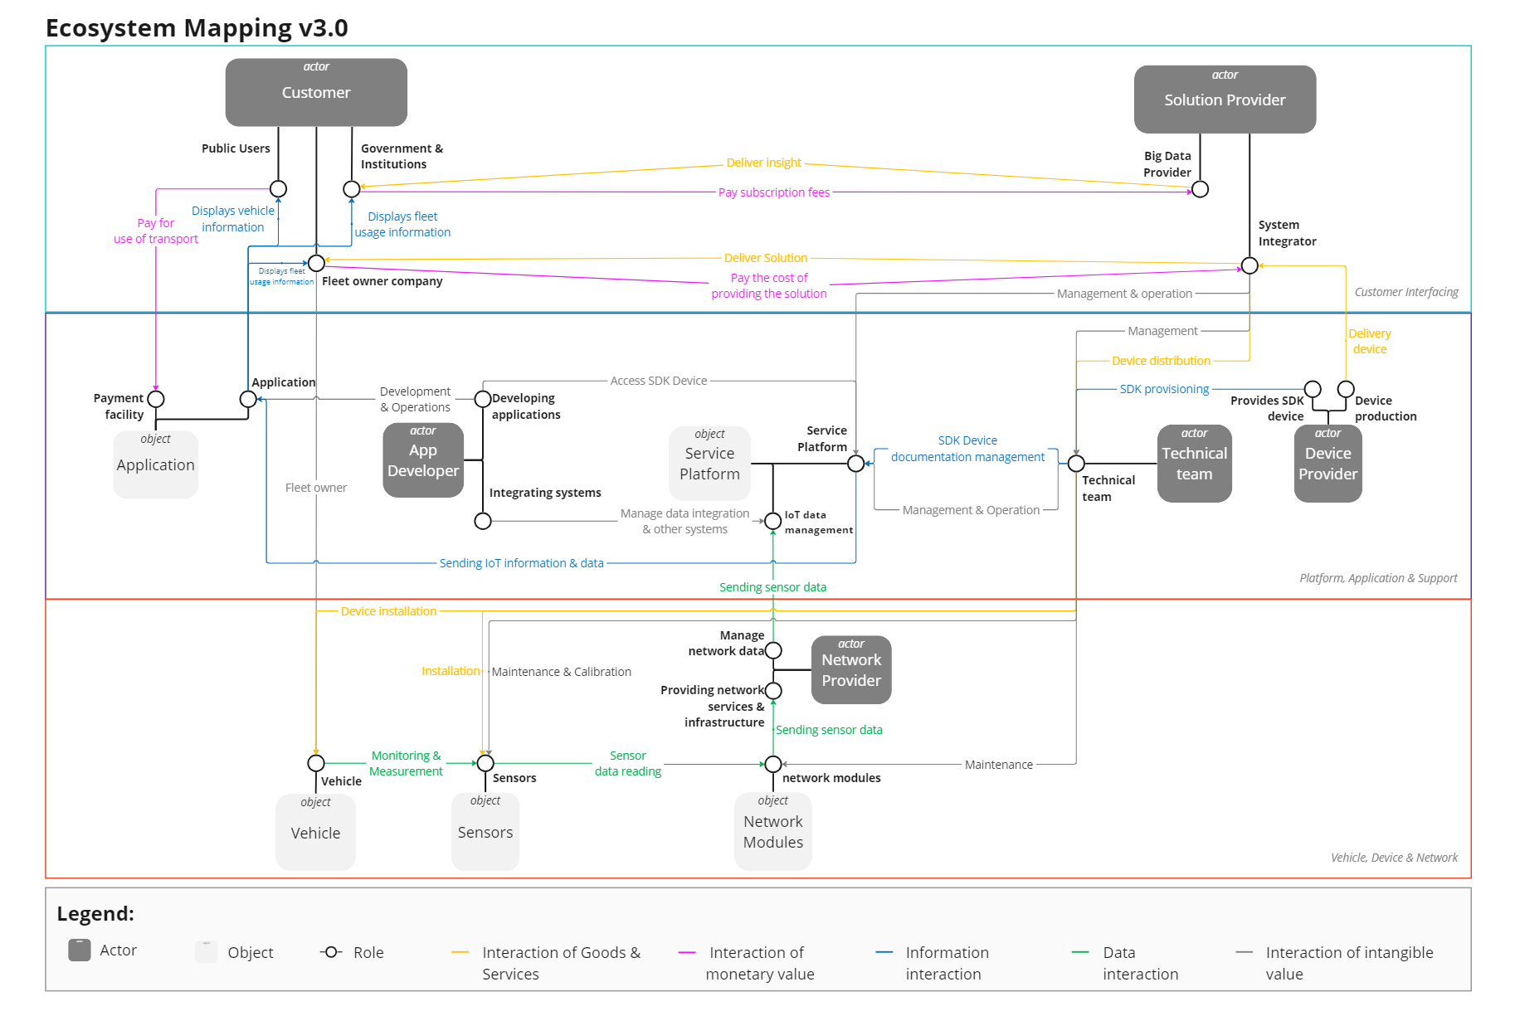
Figure 3. Mapping the IoT Transportation Business Ecosystem at Telkom Indonesia
The actors in the IoT transportation solutions ecosystem include a wide range of stakeholders, from the general public using public transportation services to governments and fleet-owning companies. The community can enjoy the convenience of facilities such as digital payments and real-time transportation tracking. On the other hand, the government and institutions like the Transportation Agency are utilizing big data services to enhance the quality of public transportation. Fleet companies, such as Transjakarta and Biofarma, also utilize IoT solutions to optimize fleet operations and conduct tracking.
The actor solution provider plays the role of a fleet management solution provider and system integrator, ensuring the efficient implementation of IoT systems. They are responsible for providing the latest IoT technology to enhance productivity and reduce operational costs. Telkom Tribe IoT functions as a system integrator and big data provider, assisting customers in achieving better fleet management goals. Actor device provider supplies the necessary hardware for IoT development, including integrated devices and Software Development Kit (SDK). Several entities, such as PINS Company and Teltonika, are collaborating to ensure the availability of devices that meet the needs of IoT services. This collaboration involves the Antares platform as a service platform for end-to-end IoT solutions.
The technical team supports the integration, maintenance, and installation of devices. This team is responsible for ensuring the reliability of hardware and software in the IoT development project in the transportation sector. They must collaborate with various parties, including device manufacturers and software developers, to create safe and efficient solutions. The actor network provider, consisting of Telkomsel and Telkom Indonesia, provides services and network infrastructure for data transmission between devices. They must ensure extensive network coverage and reliable quality, especially in areas with high mobility. An app developer acts to develop applications for customers, collaborating with internal and external teams to ensure the application functions well and can communicate effectively with IoT devices.
The service platform object functions to manage the components of the IoT ecosystem, including data from devices and sensors. Platforms like IndiCar and Antares play a crucial role in data management and application development. The application object serves as an interface for users to interact with the IoT system, such as fleet management applications and payment facilities. The vehicle object is a vehicle equipped with devices and sensors to collect IoT data. Sensor objects, such as GPS and accelerometers, are used to detect the location and changes in the vehicle's speed. Terakhis, network module objects provide the necessary connectivity in transportation IoT solutions, such as WiFi, Bluetooth, RFID, and LoRa. All these actors and objects interact with each other to create an efficient and integrated IoT solution ecosystem in the transportation sector.
This verification process ultimately reveals how the IoT transportation business ecosystem is built from various actors and objects that interact with each other to ensure that the ecosystem has been accurately designed to represent its physical and business systems. Then, in the next stages, potential changes that may occur in the future can be studied; this stage can be carried out by designing an ecosystem roadmap consisting of several transition stages to achieve the desired future IoT business ecosystem, referred to as the expanded/shifted ecosystem (Ma et al., 2021).
Through collaboration among actors, not only does it facilitate the implementation of IoT technology, but it also plays a role in optimizing transportation operations, enhancing user experience, and reducing environmental impact by introducing more efficient and sustainable solutions. Detailed interaction among elements involving actors with the aim of modeling a consistent ecosystem (Wortmann et al., 2021). In the case of Telkom Indonesia, it not only plays a crucial role in the IoT business ecosystem within the transportation sector but also acts as a catalyst in realizing digital transformation in the transportation industry in Indonesia. Telkom Indonesia itself acts as a solution provider that supplies the telecommunications infrastructure underlying IoT solutions in the transportation sector. Additionally, Telkom Indonesia also serves as an aggregator, playing a role in integrating various IoT solutions from different service and technology providers. In this regard, collaboration with other actors to support integrated IoT solutions presents an opportunity to enhance this IoT business ecosystem.
The IoT transportation business ecosystem of Telkom Indonesia includes key players such as service providers, device suppliers, application developers, and customers. The importance of explaining the role of each actor in a business ecosystem is used to respond to every change and competitive rivalry (Almeida & Nora, 2022). The development of the IoT business ecosystem in the transportation sector at Telkom Indonesia is carried out to establish a value delivery framework for each element among actors that captures the business structure, along with its relationships with suppliers, partners, and consumers. Furthermore, the efforts made also illustrate how the IoT business ecosystem in the transportation sector at Telkom Indonesia reflects both tangible and intangible resources that offer products and services in a competitive manner.
Conclusion
The Internet of Things (IoT)-based transportation business ecosystem at Telkom Indonesia involves various actors and objects that work together to provide added value to customers and stakeholders. Collaboration and co-creation are the main strategies in building this ecosystem, where each actor is involved in providing human resources (HR), infrastructure, devices, and collaboration with the government in formulating transportation policies. The actors in this ecosystem consist of various entities that are active in the development, implementation, and utilization of IoT technology, with the aim of improving the efficiency and quality of transportation services through digital transformation. Telkom Indonesia, as one of the major players in telecommunications and information technology in Indonesia, plays an important role in driving the adoption of IoT in the transportation sector. The company serves as a telecommunications infrastructure provider that ensures fast and reliable connectivity, which is the foundation for IoT solutions. In addition, Telkom also acts as a solution provider with a technical team and application developers ready to support IoT implementation according to customer needs. Collaboration between actors, both internal and external, is key in developing solutions that are appropriate for the needs of the transportation industry. Through expertise in application and technology development, Telkom Indonesia is able to offer a variety of integrated solutions that encourage the digitalization of transportation in Indonesia.
References
Adner, R. (2017). Ecosystem as Structure: An Actionable Construct for Strategy. Journal of Management, 43(1), 39–58. https://doi.org/10.1177/0149206316678451
Almeida, G., & Nora, M. (2022). Stakeholder theory and actor-network theory: The stakeholder engagement in energy transitions. Business Strategy and the Environment, 1–13. https://doi.org/10.1002/bse.3168
Bai, G. (Ginkgo), Zhao, L., & Wang, Z. E. (2018). Advantech: evolution of its IoT ecosystem strategy. Emerald Emerging Markets Case Studies, 8(4), 1–28. https://doi.org/10.1108/EEMCS-06-2018-0131
Bruijl, G. H. T. (2018). The Relevance of Porter’s Five Forces in Today’s Innovative and Changing Business Environment. Brooklyn Journal of Corporate, Financial & Commercial Law, 15(June), 1–43.
Chan, H. C. Y. (2015). Internet of things business models. Journal of Service Science and Management, 9, 552–568. https://doi.org/10.1002/9781119173601.ch45
Chatterjee, S., & Kar, A. K. (2018). Regulation and governance of the Internet of Things in India. Digital Policy, Regulation and Governance , 20(5), 399–412. https://doi.org/10.1108/DPRG-04-2018-0017
Danivola, N., & Kuznetsova, Y. (2020). Market Analysis Instruments in the Development of the Startup Marketing Strategy. European Journal of Economics and Management, 6(2), 150–163. https://doi.org/10.46340/eujem.2020.6.2.18
Fayed, M. S. (2022). Network Generations and the Security Challenge in IoT Applications. In Computer Science: Cryptography and Security. https://doi.org/10.48550/arXiv.2201.01927
Heese, H. S., Kemahlıoğlu-Ziya, E., & Perdikaki, O. (2021). Outsourcing under Competition and Scale Economies: When to Choose a Competitor as a Supplier. Decision Sciences, 52(5), 1209–1241. https://doi.org/10.1111/deci.12449
Isabelle, D., Horak, K., McKinnon, S., & Palumbo, C. (2020). Is Porter’s five forces framework still relevant? A study of the capital/labour intensity continuum via mining and IT industries. Technology Innovation Management Review, 10(6), 28–41. https://doi.org/10.22215/timreview/1366
Jüttner, U., Christopher, M., & Baker, S. (2007). Demand chain management-integrating marketing and supply chain management. Industrial Marketing Management, 36(3), 377–392. https://doi.org/10.1016/j.indmarman.2005.10.003
Kahle, J. H., Marcon, É., Ghezzi, A., & Frank, A. G. (2020). Smart Products value creation in SMEs innovation ecosystems. Technological Forecasting and Social Change, 156, 1–14. https://doi.org/10.1016/j.techfore.2020.120024
Kreutzer, R. T. (2019). Tools for the Strategic Analysis. In Toolbox for Marketing and Management: Creative Concepts, Forecasting Methods, and Analytical Instruments (pp. 89–142). Springer Cham. https://doi.org/10.1007/978-3-030-13823-3
Lee, C., Lee, K., & Pennings, J. M. (2001). Internal capabilities, external networks, and performance: A study on technology-based ventures. Strategic Management Journal, 22(6–7), 615–640. https://doi.org/10.1002/smj.181
Lehtinen, J., & Aaltonen, K. (2020). Organizing external stakeholder engagement in inter-organizational projects: Opening the black box. International Journal of Project Management, 38(2), 85–98. https://doi.org/10.1016/j.ijproman.2019.12.001
Linde, L., Frishammar, J., & Parida, V. (2023). Revenue Models for Digital Servitization: A Value Capture Framework for Designing, Developing, and Scaling Digital Services. IEEE Transactions on Engineering Management, 70(1), 82–97. https://doi.org/10.1109/TEM.2021.3053386
Lingens, B., Böger, M., Gackstatter, S., & Lemaire, A. (2019). Business ecosystems: Partnership of equals for corporates, SMEs and startups. Jerman: Roland Berger Focus.
Ma, Z., Christensen, K., & Jørgensen, B. N. (2021). Business ecosystem architecture development: a case study of Electric Vehicle home charging. Energy Informatics, 4(9), 1–38. https://doi.org/10.1186/s42162-021-00142-y
Milanova, V., & Maas, P. (2017). Sharing intangibles: Uncovering individual motives for engagement in a sharing service setting. Journal of Business Research, 75, 159–171. https://doi.org/10.1016/j.jbusres.2017.02.002
Ministry of Communications and Informatics. (2022). IoT Creation 2022 Dorong Percepatan Implementasi Internet of Things di Indonesia. https://sdppi.kominfo.go.id/berita-iot-creation-2022-dorong-percepatan-implementasi-internet-of-things-di-indo-27-5530
Ogunranti, G. A., Ceryan, O., & Banerjee, A. (2021). Buyer-supplier currency exchange rate flexibility contracts in global supply chains. European Journal of Operational Research, 288(2), 420–435. https://doi.org/10.1016/j.ejor.2020.05.053
Othman, K. (2022). Exploring the implications of autonomous vehicles: a comprehensive review. In Innovative Infrastructure Solutions (Vol. 7, Issue 2). Springer International Publishing. https://doi.org/10.1007/s41062-022-00763-6
Panico, C., & Cennamo, C. (2022). User preferences and strategic interactions in platform ecosystems. Strategic Management Journal, 43(3), 507–529. https://doi.org/10.1002/smj.3149
Putera, G. A., & Heikal, J. (2021). Business Strategy of Indah Kiat Pulp and Paper Perawang Mill, Riau, Indonesia using PESTLE, Porter’s Five Forces, and SWOT Analysis under SOSTAC® Framework. International Journal of Scientific Research in Science and Technology, 8(6), 252–270. https://doi.org/10.32628/ijsrst218624
Radonjic-Simic, M., & Pfisterer, D. (2019). A Decentralized Business Ecosystem Model for Complex Products. In Lecture Notes on Data Engineering and Communications Technologies (Vol. 21). https://doi.org/10.1007/978-3-319-93940-7_2
Rong, K., Hu, G., Lin, Y., Shi, Y., & Guo, L. (2015). Understanding business ecosystem using a 6C framework in Internet-of-Things-based sectors. International Journal of Production Economics, 159(2014), 41–55. https://doi.org/10.1016/j.ijpe.2014.09.003
Sallam, K., Mohamed, M., & Wagdy Mohamed, A. (2023). Internet of Things (IoT) in Supply Chain Management: Challenges, Opportunities, and Best Practices. Sustainable Machine Intelligence Journal, 2, 1–32. https://doi.org/10.61185/smij.2023.22103
Sanchez, M., Exposito, E., & Aguilar, J. (2020). Industry 4.0: survey from a system integration perspective. International Journal of Computer Integrated Manufacturing, 33(10–11), 1017–1041. https://doi.org/10.1080/0951192X.2020.1775295
Tricahyono, D., & Purnamasari, S. R. (2018). Business ecosystem of SMEs with value network analysis approach: A case study at Binong Jati Knitting Industrial Centre (BJKIC) Bandung. Pertanika Journal of Social Sciences and Humanities, 26, 113–118.
van Kranenburg, R., & Bassi, A. (2012). IoT Challenges. Communications in Mobile Computing, 1(1), 1–5. https://doi.org/10.1186/2192-1121-1-9
Wieringa, R., Engelsman, W., Gordijn, J., & Ionita, D. (2019). A business ecosystem architecture modeling framework. Proceedings - 21st IEEE Conference on Business Informatics, CBI 2019, 1, 147–156. https://doi.org/10.1109/CBI.2019.00024
Wortmann, F., Kämmerling, S., Ellermann, K., Kühn, A., Plass, C., & Dumitrescu, R. (2021). Development and evaluation of IoT-based platform business models in business-to-business. Stuttgart Symposium for Product Development 2021, 1–12.
Yulianto, A. (2023). Pasar IoT di Indonesia pada 2025 Diprediksi Capai Rp 572,7 Triliun. https://ekonomi.republika.co.id/berita/rrkde1396/pasar-iot-di-indonesia-pada-2025-diprediksi-capai-rp-5727-triliun
Zhang, M., Guo, Z., Zheng, H., & Zuo, W. (2016). Research on the Innovation of Business Ecosystem Model in China’s 0nline Food Reservation Market at Sharing Economic Era. 15th Wuhan International Conference on E-Business, WHICEB 2016, 78–85.

